1. Please move the status drop down from its current location to directly below the Options tick boxes (as shown in pic below)   
     
   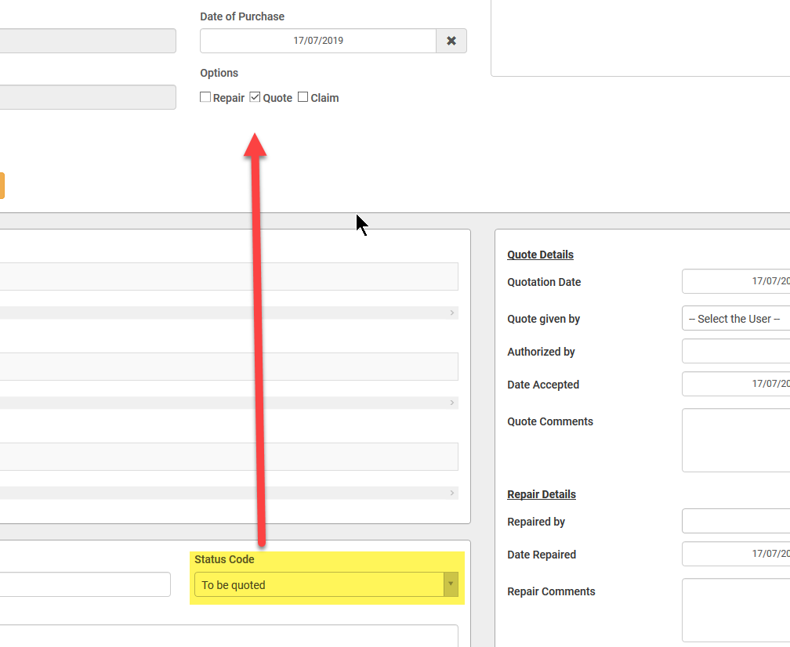
2. Rename green button to “Generate & Send Email”  
     
   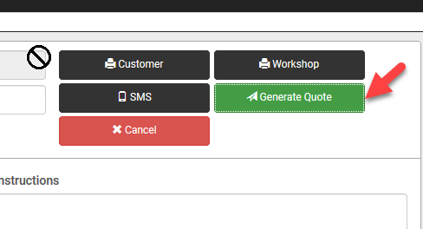
3. Add new button called Customer/Workshop Copy (it must have a Printer icon next to left of the text). When clicked it must generate and print both PDF customer and workshop copy.  
   Make the button Blue in colour.  
     
   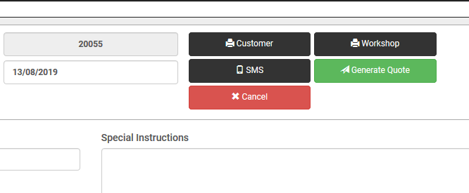
4. Reports:  
     
   The report works however I need the following change done:  
      
   If I search for a company name and DO NOT SELECT a status (that is leave the status as Select), it must show me all job cards for that company for all statuses.  
     
   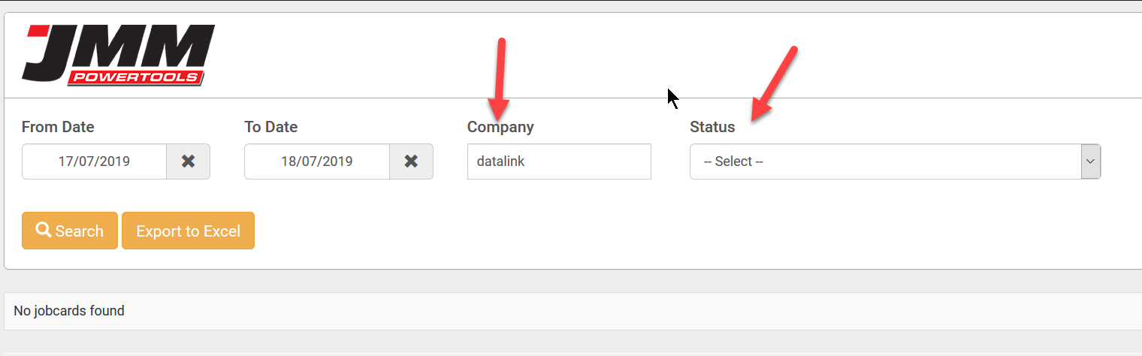  
     
     
   To put this in an easy to understand way:  
     
   For the **Status dropdown menu** change the word “Select: to the word “All”. All must be be the default. When “All” is selected the user MUST enter a company name . Once the user selects the date range and clicks the **Search** button it must fetch and display all the records for that particular customer irrespective of status.   
     
   Results grid should show different columns based on the status what is chosen.   
     
   If the Status “**All**” is selected then these are the headings that must display in the grid:  
     
   Job No,   
   Date,   
   Status,   
   Company Name,   
   Make,   
   Model,   
   Description,   
   Serial No,  
   Contact Person.  
     
   If ANY other status is selected then these are the headings that must display in the grid:  
     
   Job No, Date,   
   Status,   
   Company Name,   
   Tel No,   
   Make,   
   Model,   
   Description,   
   Serial No,   
   Repaired By,   
   Repaired Date,   
   Quote Amt(R),   
   Quoted By,   
   Received By,   
   Invoice No,   
   Order Date.  
     
   NOTE: Company Name can be blank. Company Name is not mandatory if the user chooses a status other than ALL.  
     
   This report is exported to PDF and also in Excel. The columns are exactly what is shown in the results grid. This report should be in landscape.

1. Reports:  
     
   When we export to Excel, what is shown on screen must be the same info that is exported to Excel.  
   Now, different info is being exported to what is shown on screen. Please fix.  
     
   See pic below, I search for customer Datalink:  
   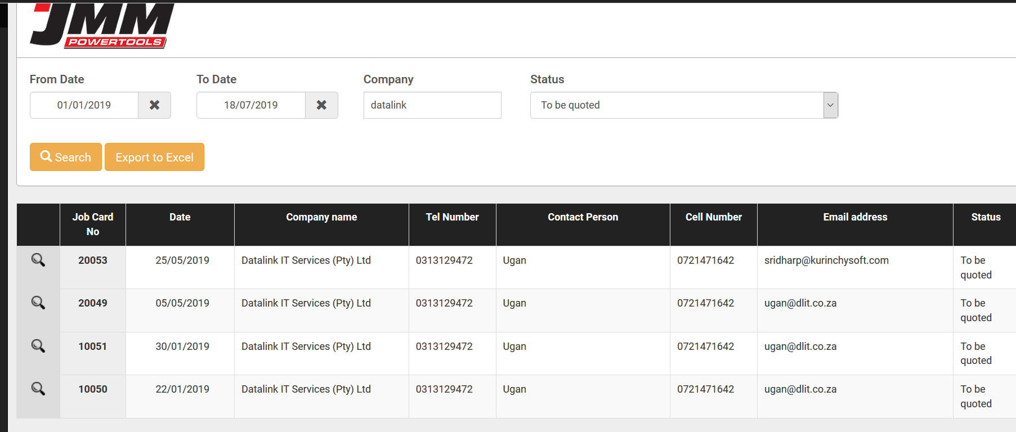  
     
   When I exported to Excel, this is what as shown:  
     
   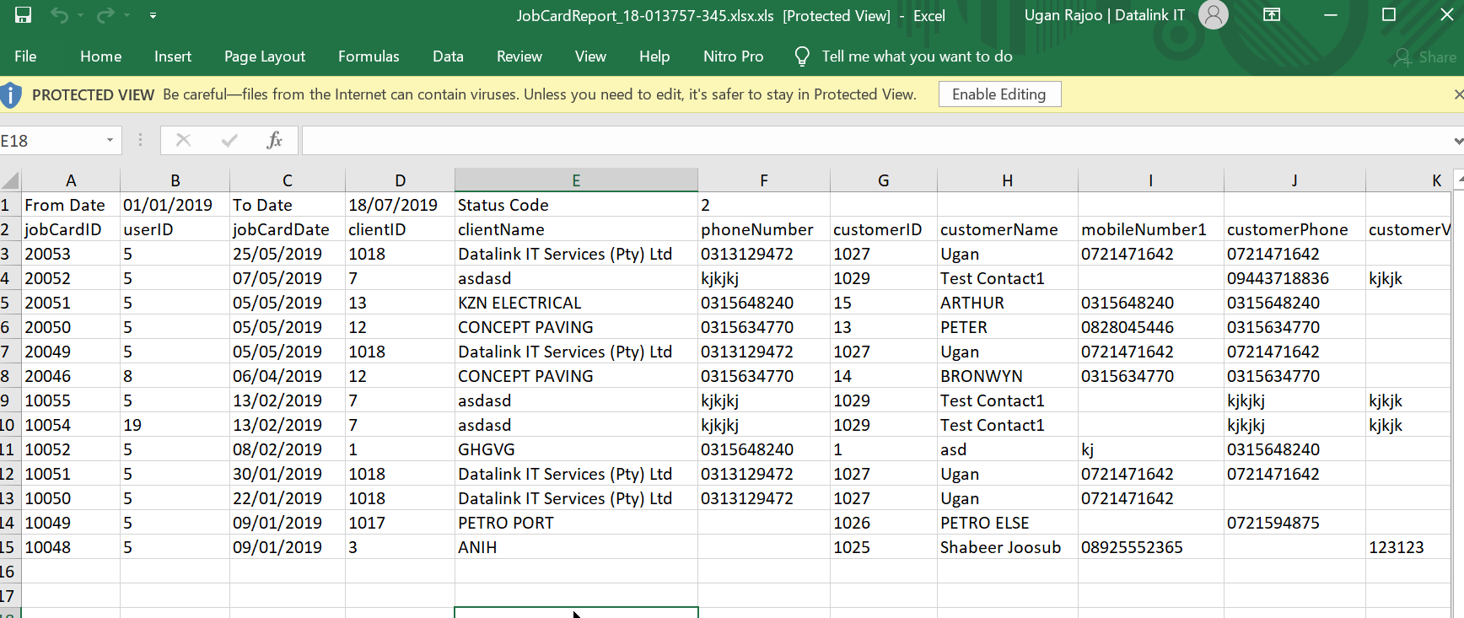  
     
     
   It must only export what is showing in the results grid. If the company is only one, then only one company must be exported. The columns what is shown in the results should be exported. There should not be any other additional columns in the exported excel.
2. For the PDF that is generated for Customer Copy and Workshop copy, we need the terms and conditions to appear on the first page. It must look like this:  
     
   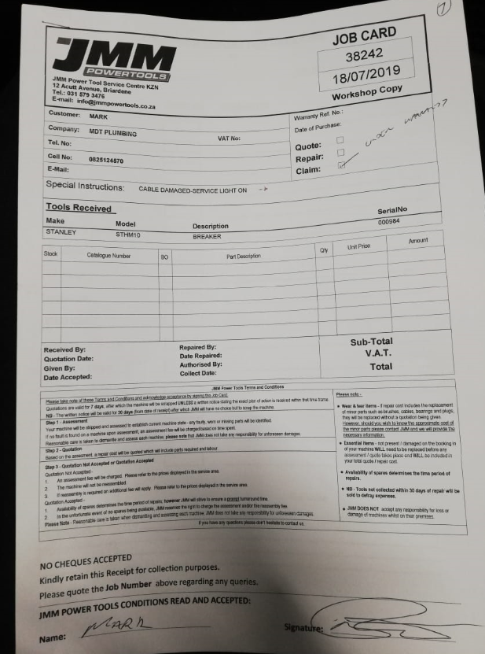  
     
   This PDF should be one page. It should not be in two pages. User wants everything in one page. It must be for both customer copy and workshop copy.   
   This is for one job card only. SO there is always only one tool. It should fit into one page.

1. For the Customer Copy and Workshop copy PDF I need two additional text fields to appear on the FORM only (It must not appear in the web app)  
     
   Fields to be added must be:   
   - Final Assessment By:  
   - Signature:  
     
   These fields must be added at this location:  
     
   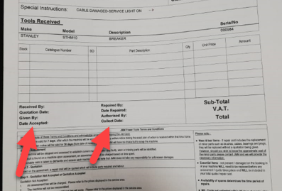
2. When Making a Job Card, we must be able to select only 1 of these tick boxes ONLY. Right now we can tick all three.   
   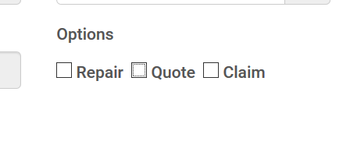
3. When viewing a Report, can you please add in columns that show the Tools that appear for each Job Card. Each Job Card will ONLY have 1 tool. We simply need to show the Make & Model of the Tools when we search for a Job Card.  
     
   This must also be exportable to Excel and PDF.